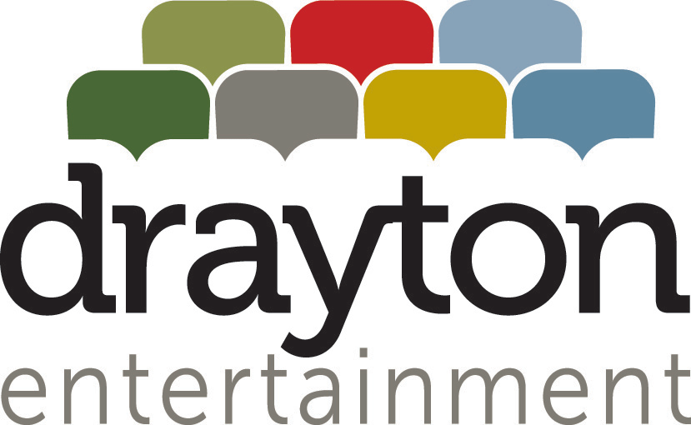

ORGANIZATION DESCRIPTION
Drayton Entertainment is a registered, not-for-profit charitable organization and one of Canada's most successful professional theatre companies. We present the finest in live theatre for all ages at seven unique venues across Ontario: the Drayton Festival Theatre in Drayton, Huron Country Playhouse (Mainstage and South Huron Stage) in Grand Bend, King's Wharf Theatre in Penetanguishene, St. Jacobs Country Playhouse and Hildebrand Schoolhouse Theatre in St. Jacobs, and the Hamilton Family Theatre Cambridge. We also operate a Youth Academy in Waterloo.

Drayton Entertainment is committed to inclusion and diversity in hiring, and encourages all qualified candidates to apply without regard to age, disability, ethno-cultural identity, sexual orientation, gender identity, or any other historically underrepresented and marginalized identities.

Drayton Entertainment is committed to providing all workers with a barrier free work environment free of discrimination and harassment. If reasonable accommodation is needed to participate in the employment selection process, please reach out directly to Natasha Hopf, Director of Human Resources, at natasha@draytonentertainment.com or 519-621-5511 ext.240 so that we may provide assistance.

CUSTODIAN (PART-TIME)

Reports to Facility Manager

Function Custodians are a crucial part of our team, ensuring the theatre facility is a clean, sanitized, welcoming, and safe environment on a daily basis for audiences, artists, staff, and volunteers. If you thrive working independently, enjoy completing a variety of tasks, and desire a flexible work schedule, this may be the position for you!

Duties and Responsibilities include but are not limited to:

- Perform general custodial duties to ensure cleanliness, sanitization, and maintenance of the theatre facility and grounds. This includes tasks such as cleaning floors, wiping down surfaces, and emptying trash receptacles, and pertains to public and backstage areas such as the auditorium, lobby, washrooms, dressing rooms, offices, and hallways/corridors. Additional scope of work may include the artists’ short-term residence (Cambridge and Grand Bend locations only).
- Follow all WHMIS and Occupational Health & Safety Act Guidelines, adhering to instructions for the proper use of cleaners, chemicals, and equipment.
- Adhere to the cleaning schedule and checklist as provided by the Facility Manager, including daily, weekly, and seasonal tasks.
- Report observances of property damage and make recommendations on items/issues that require repair and/or attention.
- Restock supplies in washrooms and other areas as needed, and report on the inventory of cleaning supplies.
- Monitor building security and safety when working in the building after operating hours.
- Perform other duties as needed for the purpose of ensuring the efficient and effective functioning of the theatre.

REQUIRED SKILLS & QUALIFICATIONS

- Enthusiasm for, and appreciation of, live theatre and the many people accessing the venue on a daily basis.
- Previous experience in commercial cleaning or custodial work preferred, but not required.
- Ability to perform physical task demands such as lifting, bending, and standing for extended periods of time.
- Attention to detail and pride in work ethic.
- Strong time management skills to prioritize tasks effectively.
- Ability to work independently with minimal supervision.
- Flexibility in schedule, as the position will require some early morning and/or late evening work based on theatre performance and rehearsal schedules, as well as the needs of daily business operations, rentals, and special events.

TERM: Part-time; Immediate Start.

This position is available at each of the following venues:
- Hamilton Family Theatre Cambridge (Year-Round Part-Time)
- Huron Country Playhouse, Grand Bend (Seasonal Part-Time; April 1 to Sept 30)
- Drayton Festival Theatre, Drayton (Seasonal Part-Time; April 1 to Sept 30)

Due to the nature of the live theatre industry, some evening, early morning, and weekend work will be required.

HOW TO APPLY

For consideration, interested candidates should respond with Cover Letter & CV by March 17, 2025 to:

Hamilton Family Theatre Cambridge
Jenna De Graaf, Facility Manager
Email: jennad@draytonentertainment.com

Huron Country Playhouse
Caitlyn Hill, Facility Manager
Email: caitlyn@draytonentertainment.com

Drayton Festival Theatre
Alan Card, Director of Facilities
Email: alan@draytonentertainment.com

We thank all applicants for their interest; however only those selected for an interview will be contacted.

